Phone Trasmission

* Space ship lost need to find home
* Signals , space , make path , pazzle , paths, obsticles, Movement speeds
* 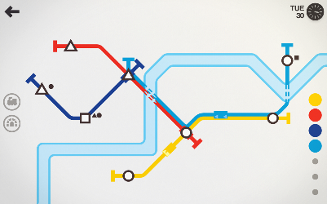
* Mail Deleverd
* Lost Ship
* Airplanes
* **Stone age . with catapolt top view 3d and stone age men**
* 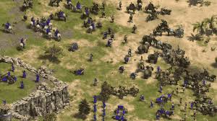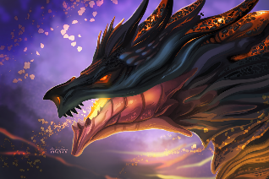

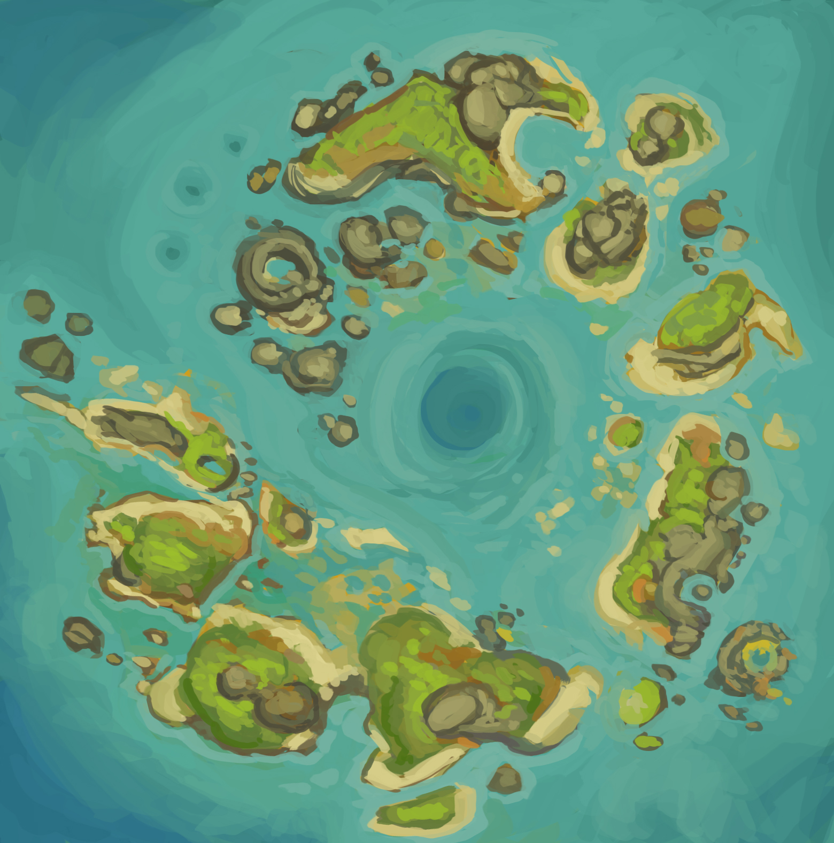

* Card like game with events based story telling
* Roge like experince where you need to deliver the message
* Laggy Transmission – Turn Based – Acquire Land
* 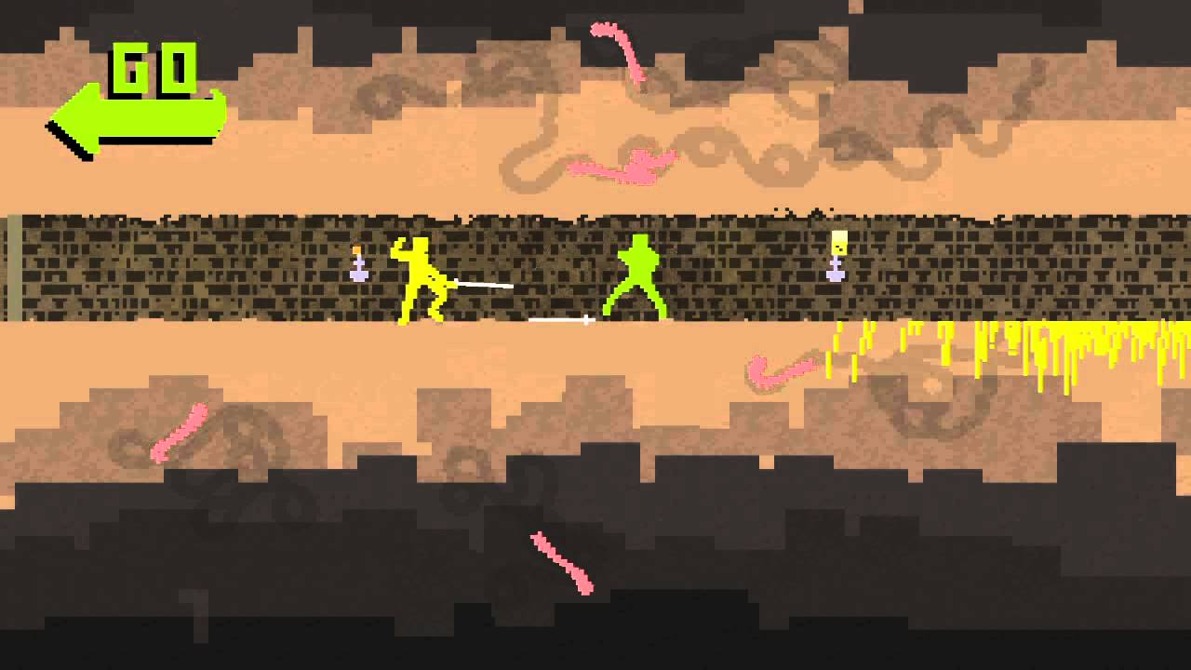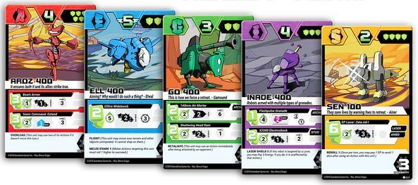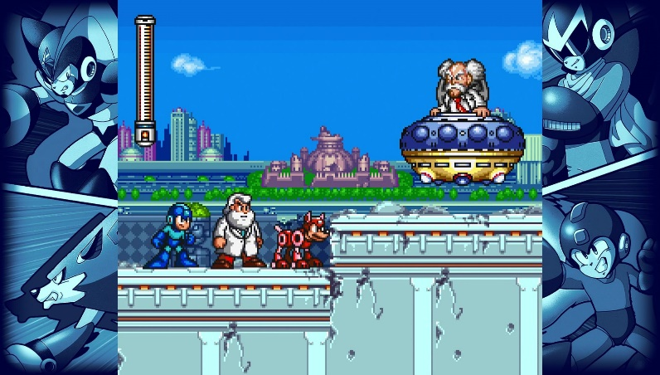

Basic Art

Characters

Effects

Actions – 3

Each event is a card which is random on each turn

Attack

Move - Direction

Evade – Direction

Progress Goal

Kill Opponent - > Change Arena -> Gain Slot -> do it again

Final Goal

Destroy the opponent base

Timelimit

Turn limit

Networking

Art Team

Basic Blockouts